**Blinkit SQL Queries**

A. KPIs

1. Total Sales

select cast(sum(Total_Sales)/1000000.0 as decimal(10,2)) as total_sales_millions

from blinkit_data;



Calculates the **total sales in millions** by summing Total_Sales and dividing by 1,000,000.

2. Average Sales

select cast(avg(Total_Sales) as int) as Avg_Sales

from blinkit_data;



Finds the **average sales value** across all records, cast as an integer

3. No. of Items

select count(*) as order_no

from blinkit_data;



Counts all rows in blinkit_data to get the **total number of items (orders)**.

4. Average Rating

select cast(avg(Rating) as decimal(10,1)) as Avg_Rating

from blinkit_data;



Calculates the **average product rating**, rounded to one decimal place.

B. Total Sales by Fat Content

select Item_Fat_Content, cast(sum(Total_Sales) as decimal(10,2)) as Total_Sales

from blinkit_data

group by Item_Fat_Content;



Shows **total sales by item fat content category** (e.g., Low Fat, Regular).

C. Total Sales by item type

select Item_Type, cast(sum(Total_Sales) as decimal(10,2)) as Total_Sales

from blinkit_data

group by Item_Type

order by Total_Sales DESC;

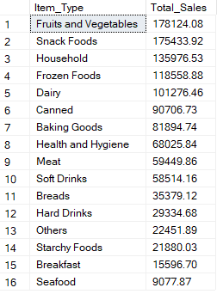

Shows **total sales by item type**, ordered from highest to lowest sales.

D. Fat Content by Outlet for Total Sales

select Outlet_Location_Type,

ISNULL([Low Fat], 0) as Low_Fat,

ISNULL([Regular], 0) as Regular

from

(select Outlet_Location_Type, Item_Fat_Content, cast(sum(Total_Sales) as decimal(10,2)) as Total_Sales

from blinkit_data

group by Outlet_Location_Type, Item_Fat_Content) as sourceTable

pivot(

sum(Total_Sales)

for Item_Fat_Content in ([Low Fat], [Regular])

) as PivotTable

order by Outlet_Location_Type;

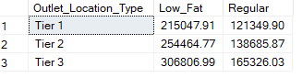

Creates a **pivot table** showing total sales of **Low Fat vs Regular items** across different outlet location types.

E. Total Sales by Outlet Establishment

select Outlet_Establishment_Year, cast(sum(Total_Sales) as decimal(10,2))

from blinkit_data

group by Outlet_Establishment_Year

order by Total_Sales desc;

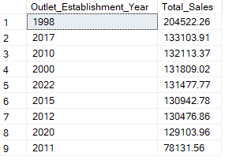

Shows **total sales by outlet establishment year**, ordered chronologically.

F. Percentage of Sales by Outlet Size

select Outlet_Size, cast(sum(Total_Sales) as decimal(10,2)) as Total_Sales,

cast((sum(Total_Sales) * 100.0 / sum(sum(Total_Sales)) over()) as decimal(10,2)) as sales_percentage

from blinkit_data

group by Outlet_Size

order by Total_Sales desc;

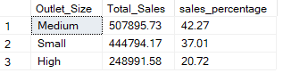

Shows **total sales by outlet size** along with each size’s **percentage contribution to overall sales**, ordered from highest to lowest sales.

G. Sales by Outlet Location

select Outlet_Location_Type, cast(sum(Total_Sales) as decimal(10,2)) as Total_Sales

from blinkit_data

group by Outlet_Location_Type

order by Total_Sales desc;

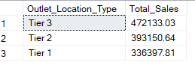

Shows **total sales by outlet location type**, ordered from highest to lowest sales.

H. All metrics by Outlet Type

select Outlet_Type,

cast(sum(Total_Sales) as decimal(10,2)) as Total_Sales,

cast(avg(Total_Sales) as decimal(10,2)) as Average_Sales,

count(*) as No_of_Items,

cast(avg(Rating) as decimal(10,2)) as Average_Rating,

cast(avg(Item_Visibility) as decimal(10,2)) as Item_Visibility

from blinkit_data

group by Outlet_Type

order by Total_Sales desc;

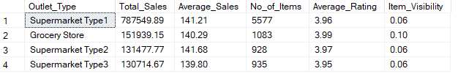

Summarizes **outlet performance by type**, showing total sales, average sales, number of items, average rating, and average item visibility.